Business Plans
Unit 1.3 Questions
- What is a business plan?
- What is the difference between enterprise and entrepreneur?

- Arthur Buttersworth is looking to set up a business plan for a high-end popcorn snack. Read the articles below and create a business plan template for him. One has been started for you. Where you do not know information, explain what Arthur should do to find it out. Try and fill in as much as you can
- http://www.thegrocer.co.uk/reports/digital-features/snack-report-2015/popcorn-sales-boom-with-38-growth/512825.article

- http://www.ibisworld.com/industry/popcorn-production.html

- http://www.foodnavigator-usa.com/Markets/Rabobank-reports-on-astounding-growth-in-RTE-popcorn
- How can the business plan above be used to measure success?
- How can the business plan above be used for accountability?

Business Plan for PopsCorn
Name of Company | PopsCorn
Idea | 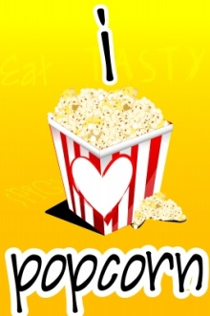  I Love Popcorn” by digitalart
Cash needed to start up
Best place to get cash from
Why consumers are interested

