Unit 1.2 Questions

- What percentage of the country above is involved in a
  - the primary sector
  - the secondary sector
  - the tertiary sector
- Look at the following data for economic output:
A B C
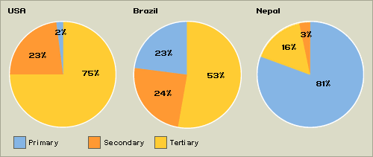
  - Which country seems most developed? Explain your answer
  - Which country would you argue is most labour-intensive? Explain your answer
  - Which country would you argue is most capital-intensive? Explain your answer
  - What is the relationship between value-added and economic sectors?
- Look at the following data for employment:
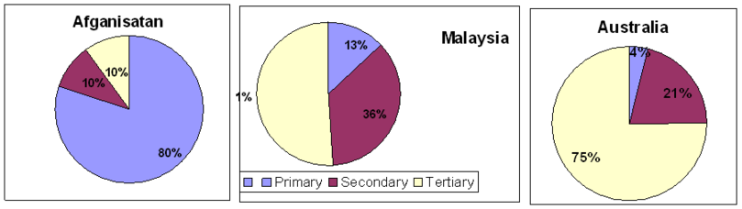
  - Australia still operates many primary sector activities, such as mining. Why are the figures on Australia’s employment a little misleading?
  - If Afghanistan had 120 000 workers in total in their country, how many are employed in the primary sector?
  - How could a country attempt to move more workers into the tertiary sector?
  - What is deindustrialization and what effect would it have on a country’s industrial sector pie charts?
- Explain two advantages of:
  - A large private sector
  - A large public sector
- If nationalization is the opposite of privatization, then explain what this terms means.

